ECS TASK
Setup a highly available ecs cluster with load balancer and dynamic port mapping.
NOTE:
Your cluster should maintain atleast 6 tasks at any point of time and should be highly availble across multiple AZ's.
Use the below image from deployment:
- Create the cluster
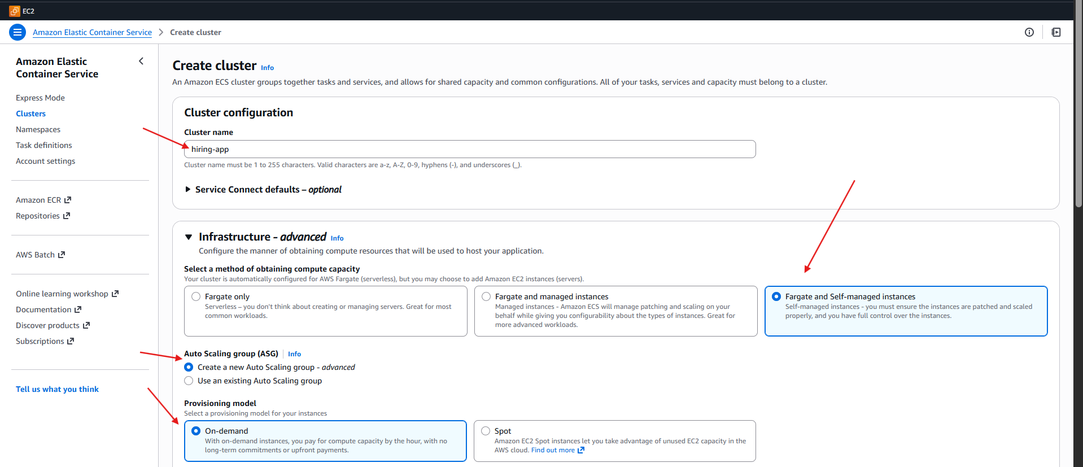
- Configure the cluster
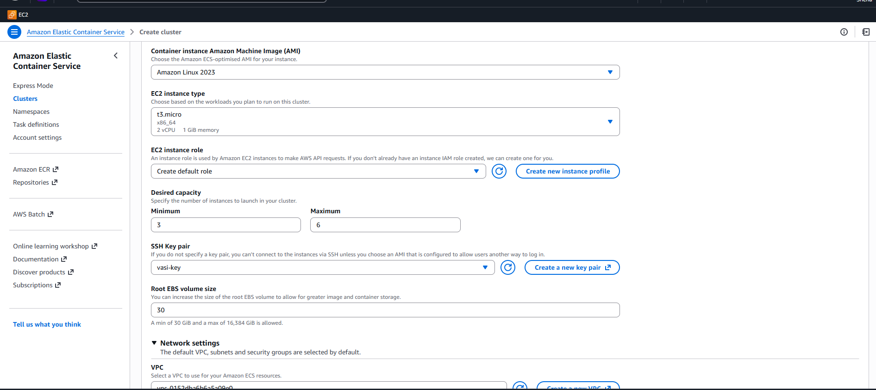
- Cluster has been created

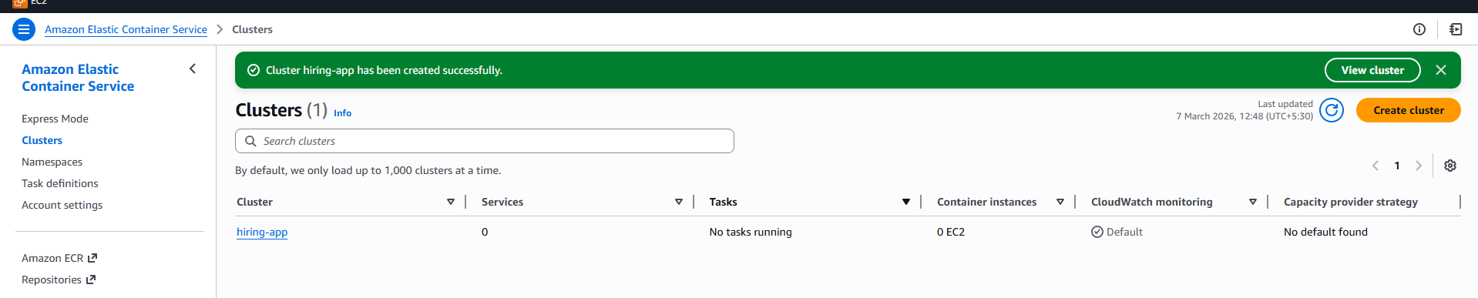
- Create new task definition
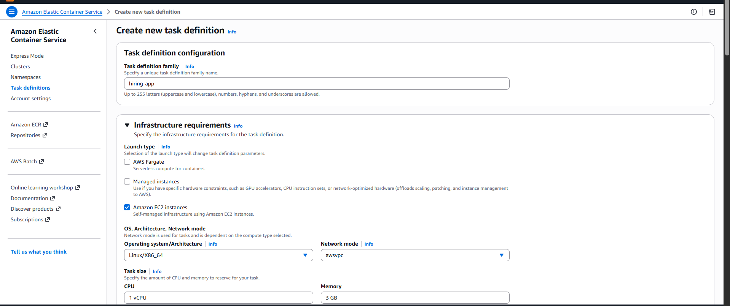
- Task defination
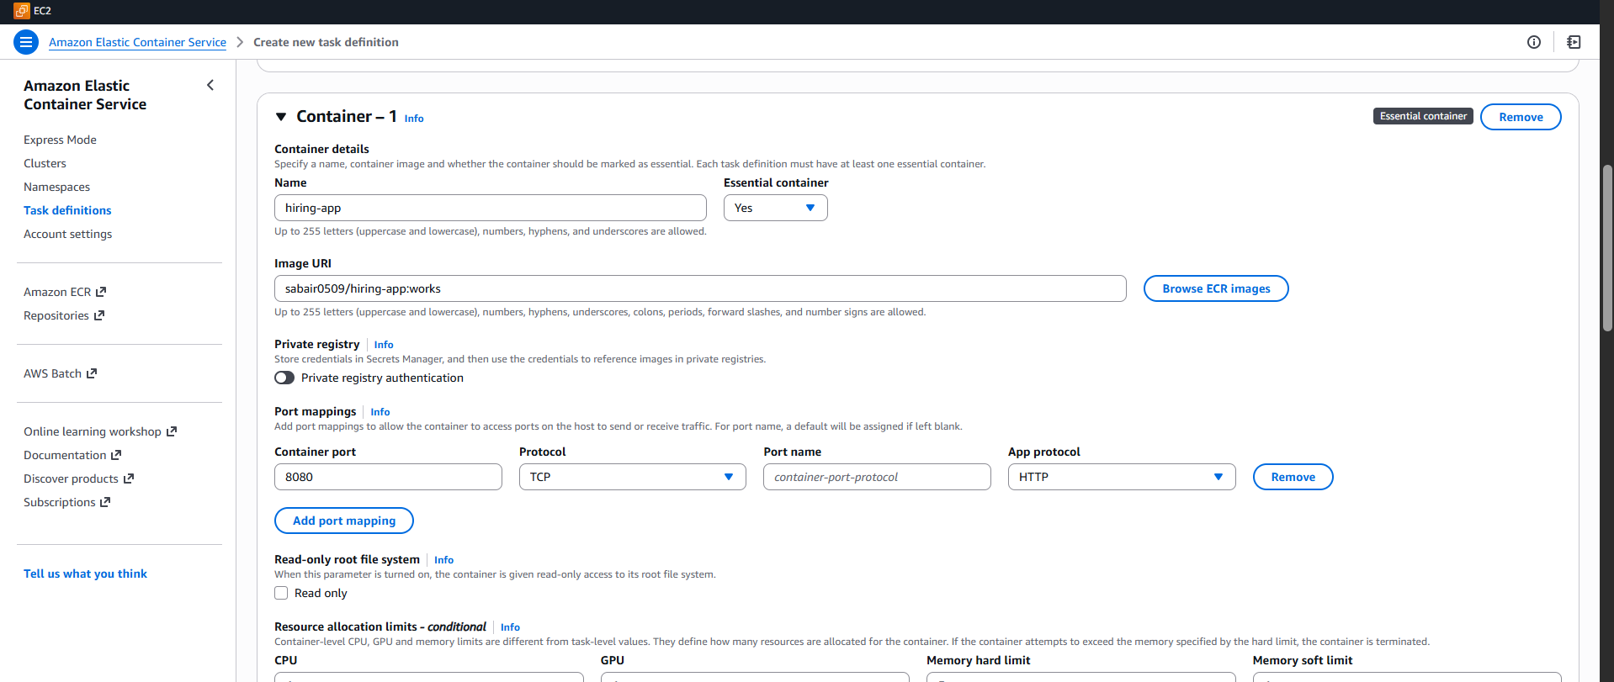
- Ecs hiring app revision-1 container
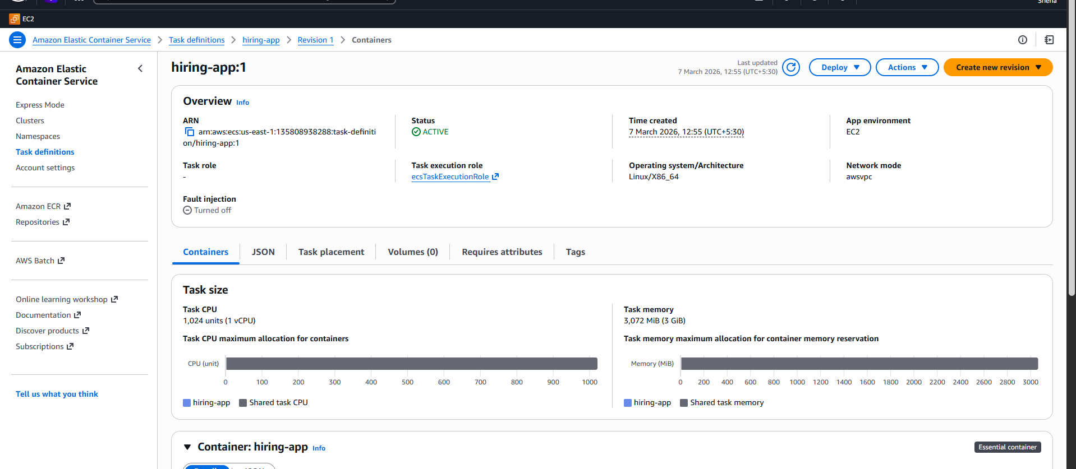
- Create application load balancer
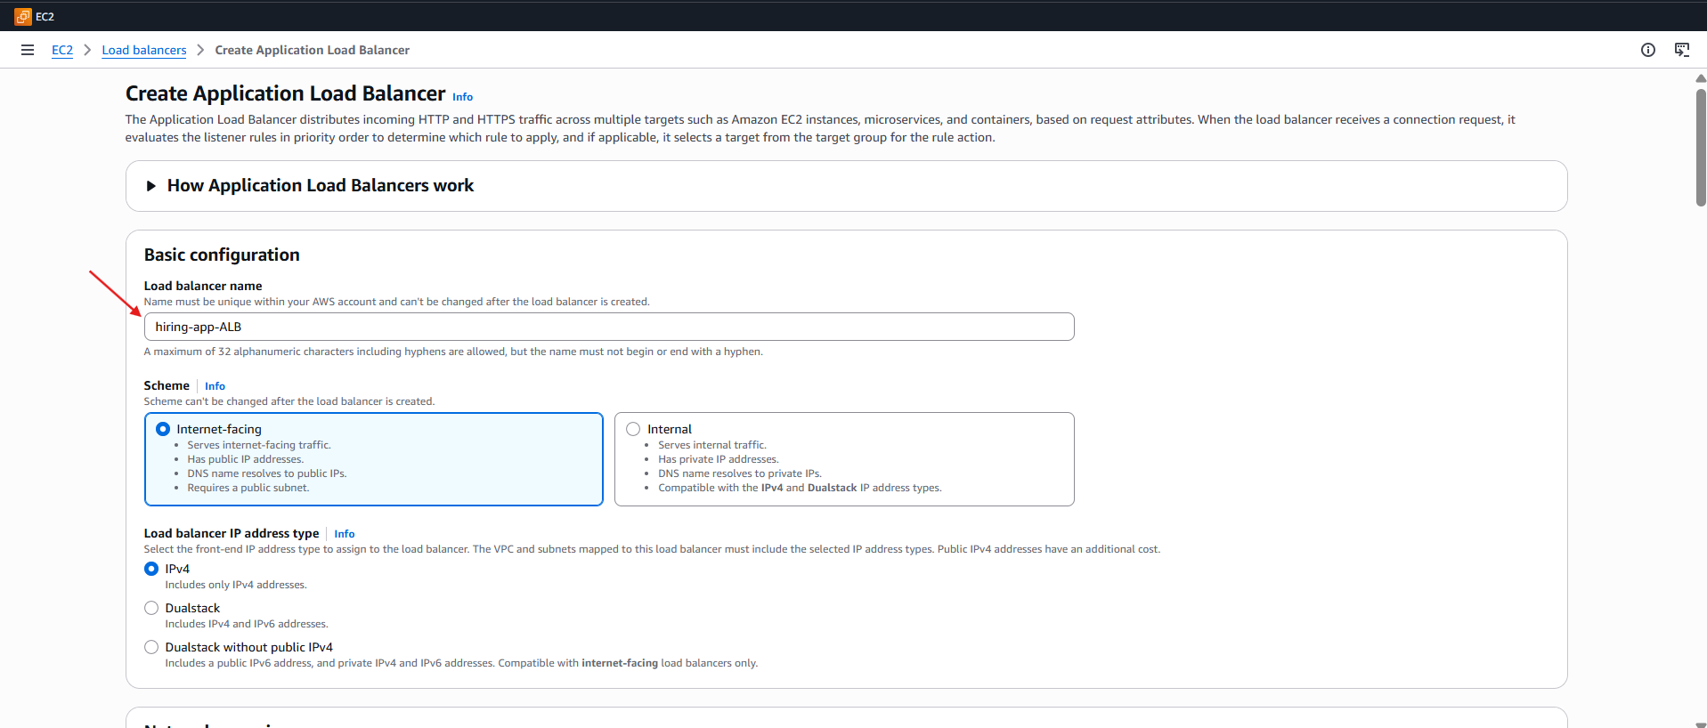
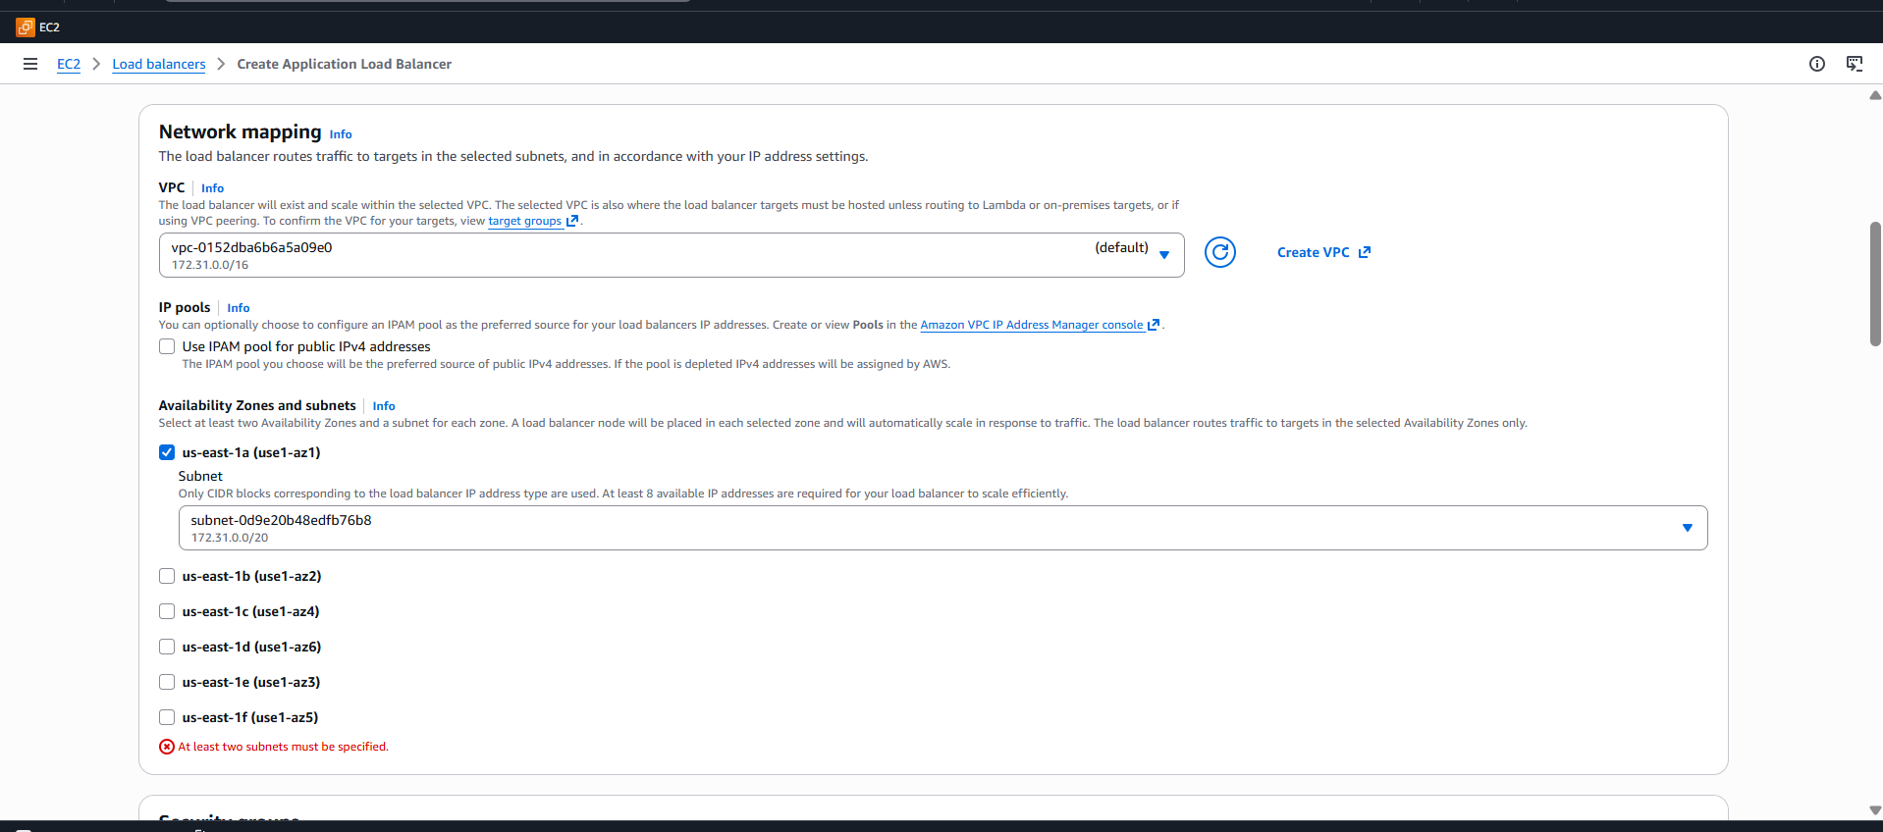

- Check the target group successfully
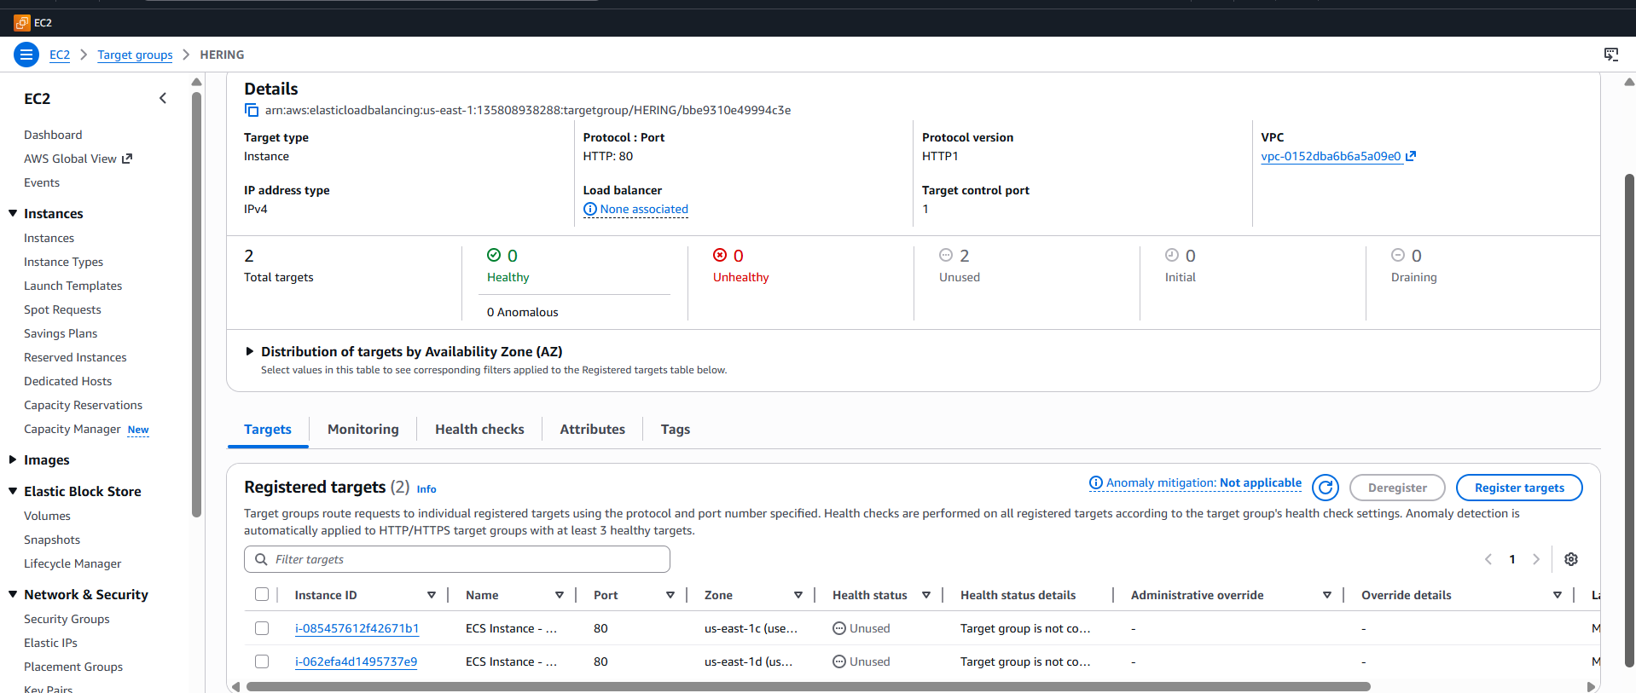
- Check the network mapping
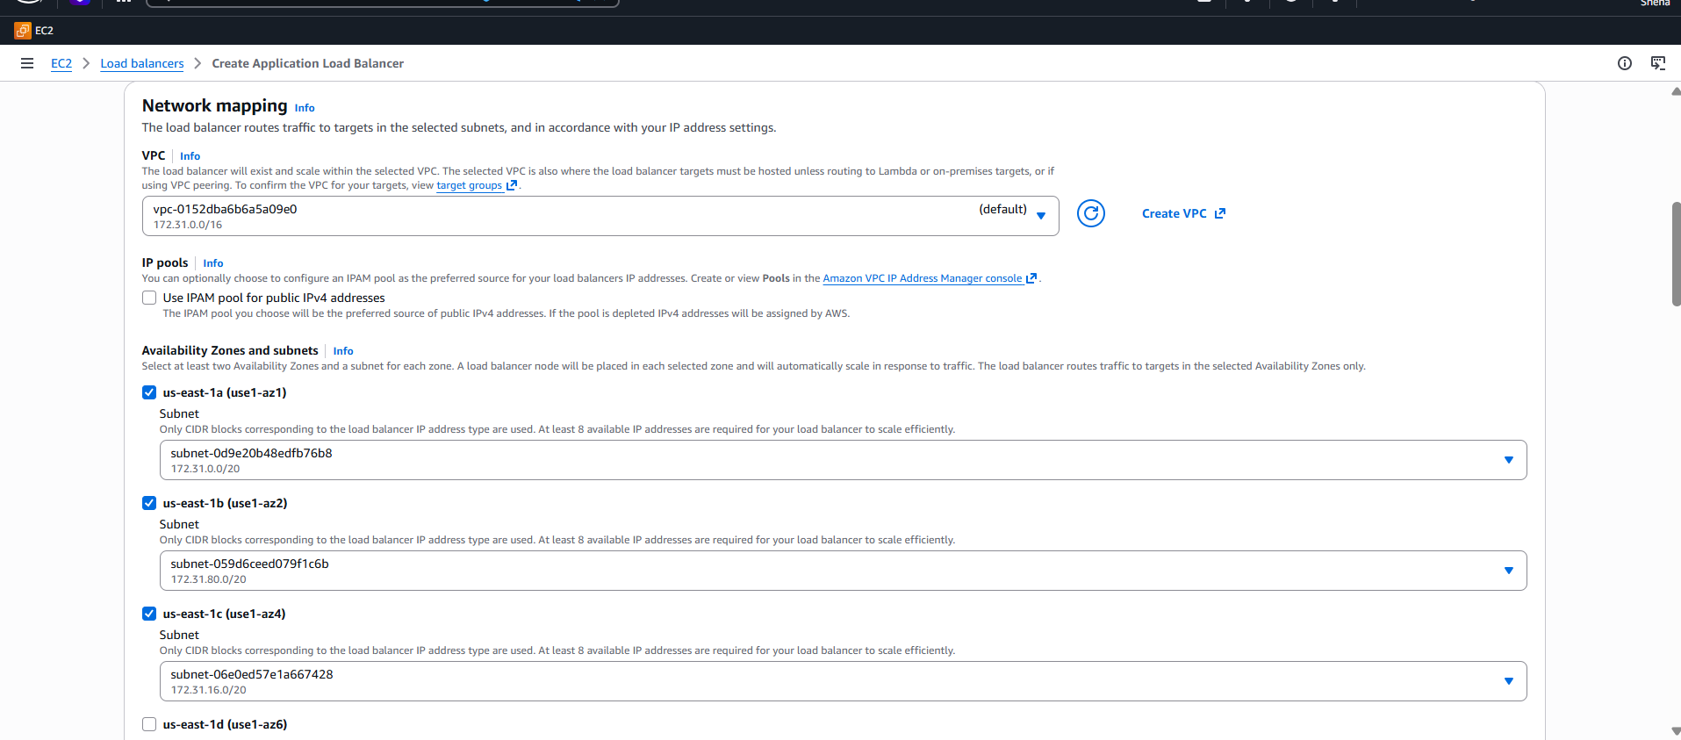
- Check the listeners and routing
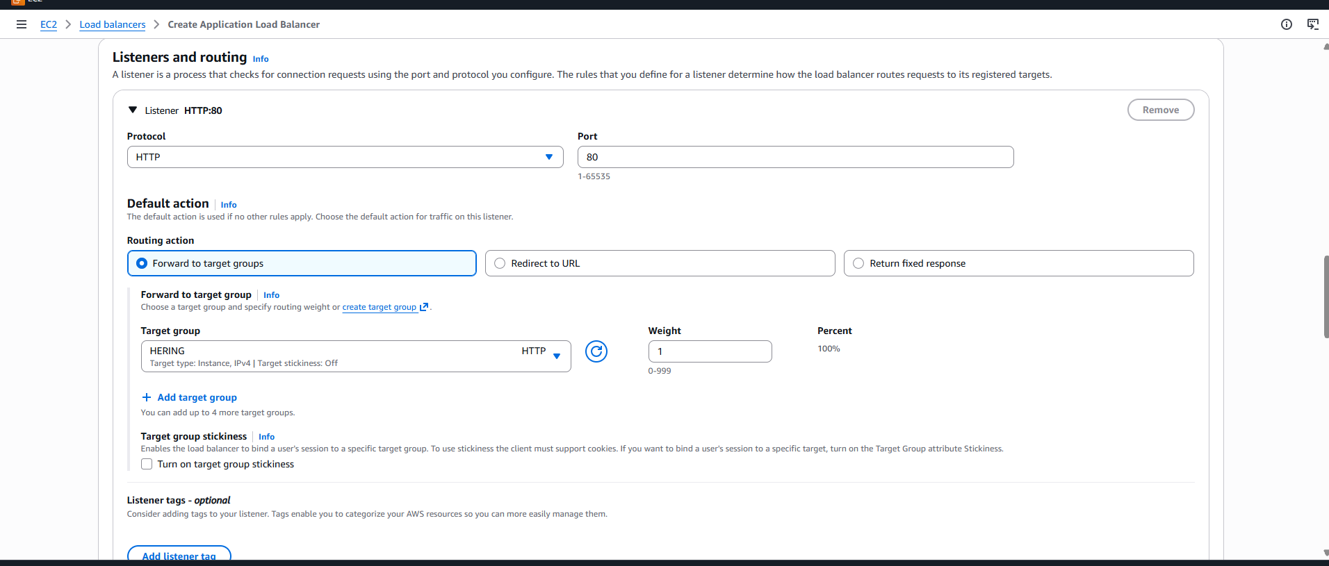
- Load balancer is created

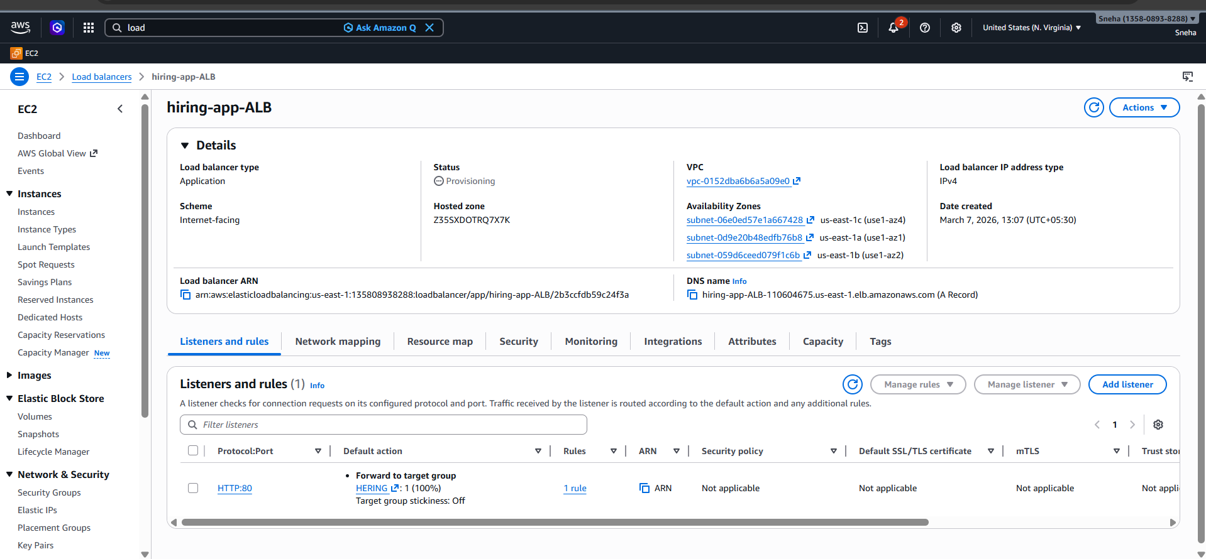
- Cluster service verification
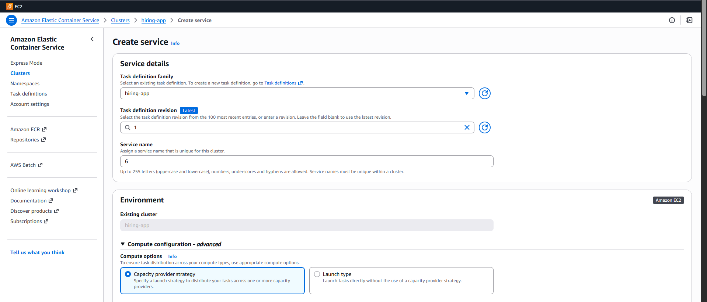
- Deployment configuerationreplica
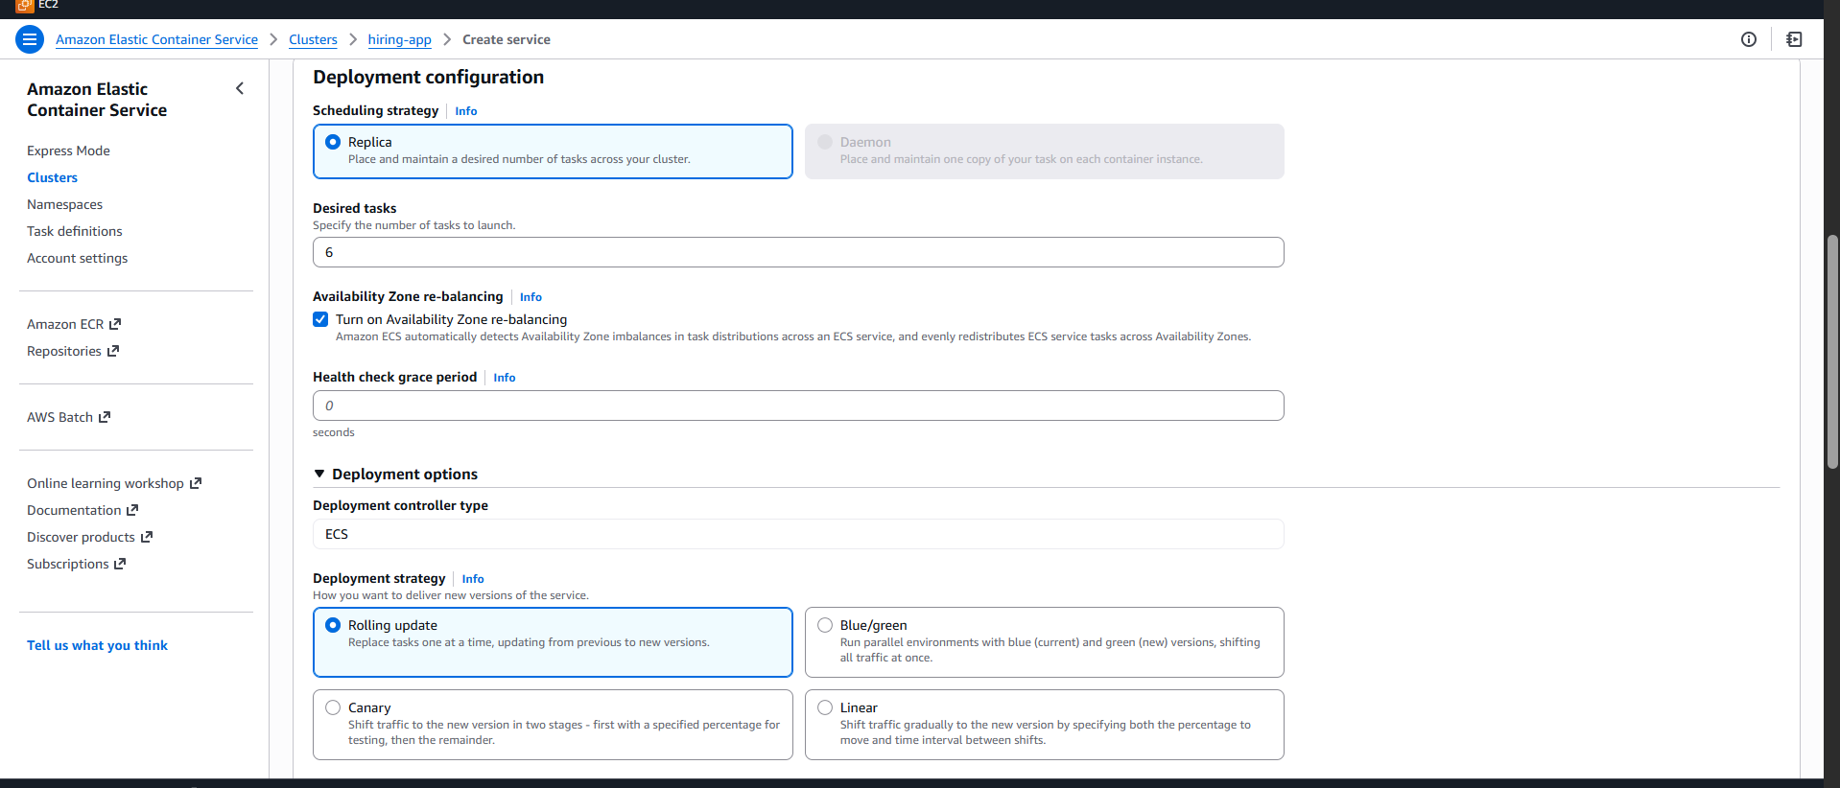
- Application load balancer create
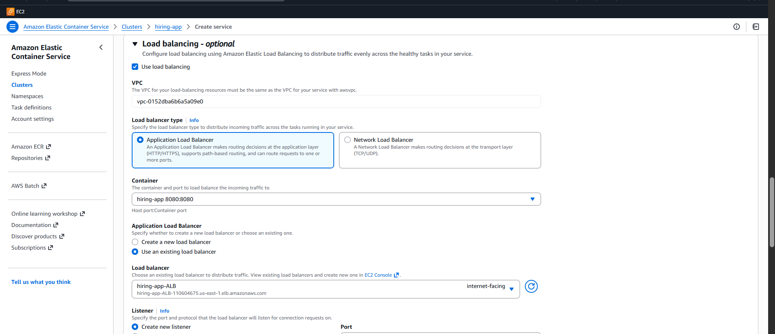
- Validation: Naviagate to à hiring-app-cluster à Service tab
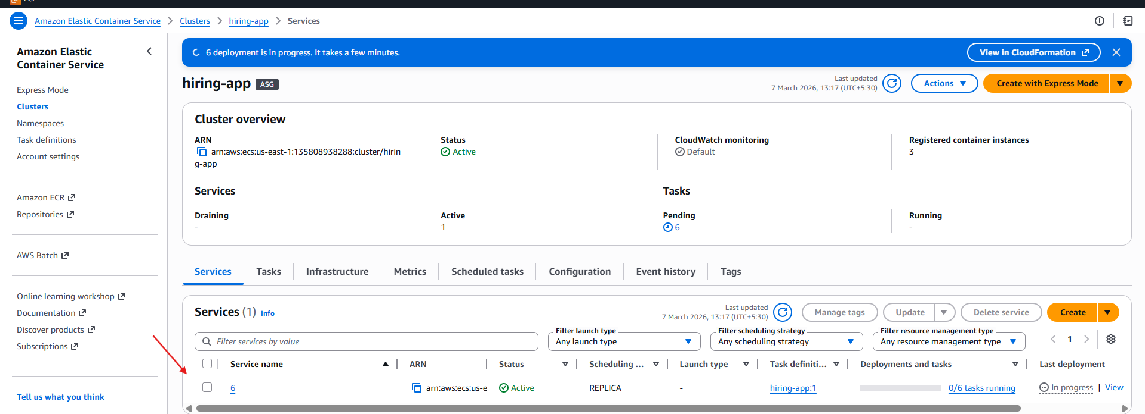
- ALB → Distributes traffic across multiple AZs
- EC2 ASG → Replaces failed EC2 instances
- ECS Service → Maintains minimum 6 running tasks
- Health Checks → Automatically removes unhealthy containers
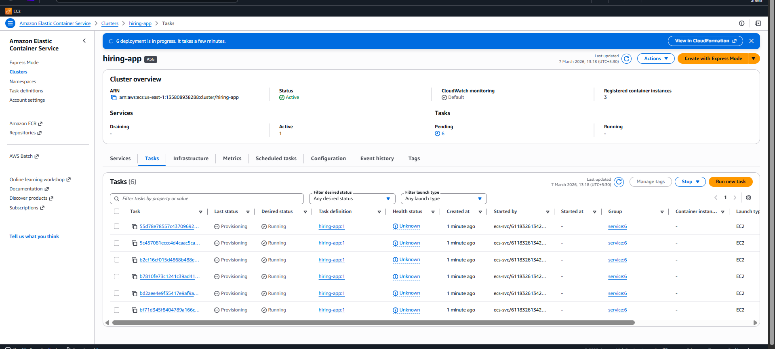
- Navigate to S.G of instances from ECS à Edit-Inbound Rules à Add this < 8080 >
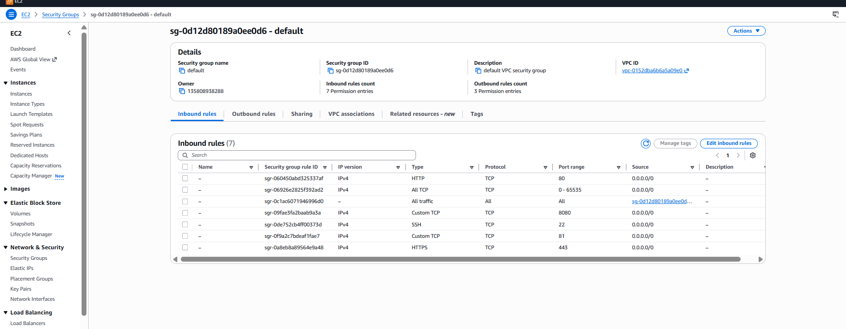
- Verification
You checked:
ECS → Running Tasks = 3
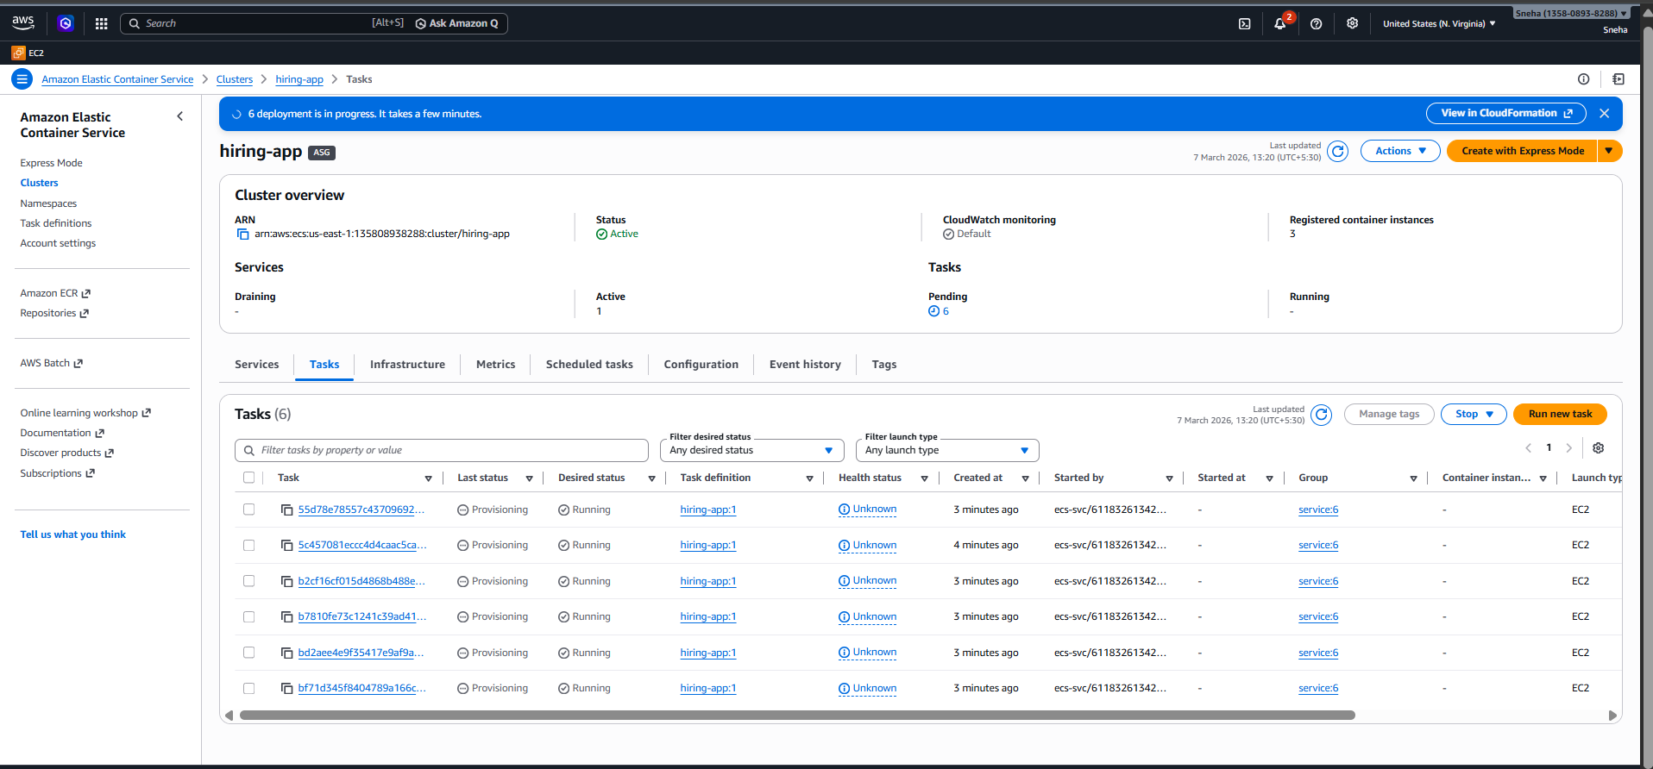
- Check the running instances
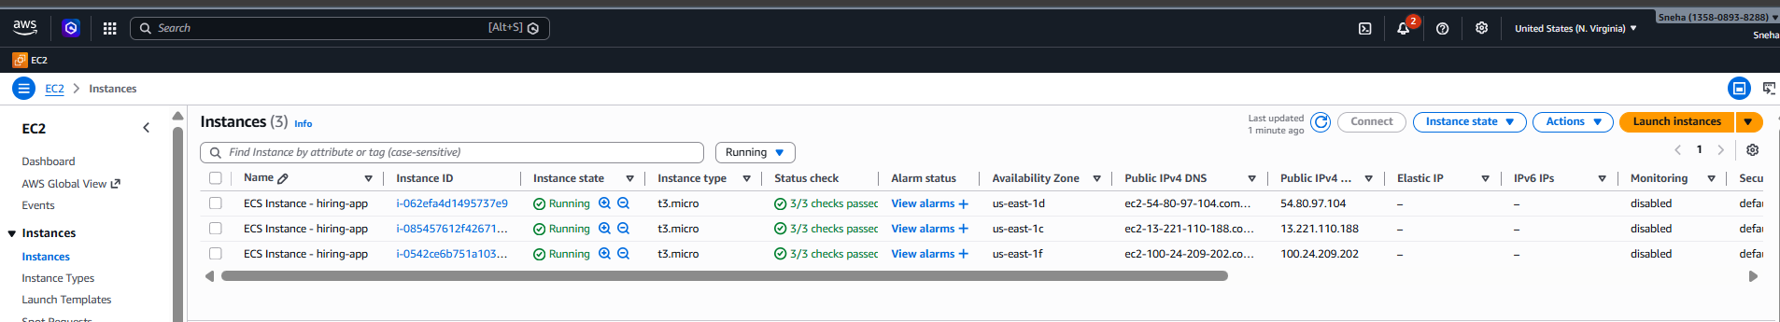
- Check the application load balancer
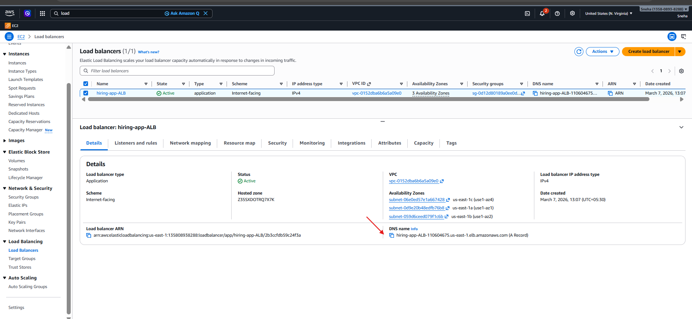

- Deployment is successfull


